MKF-PJS04 series
Mate Industrial Joystick, Hall / Potentiometer effect, Dual axis, Panel Mounted

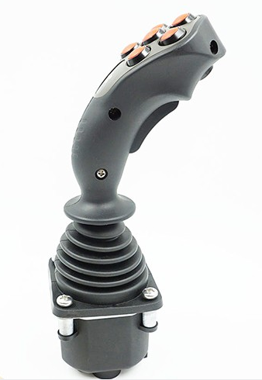
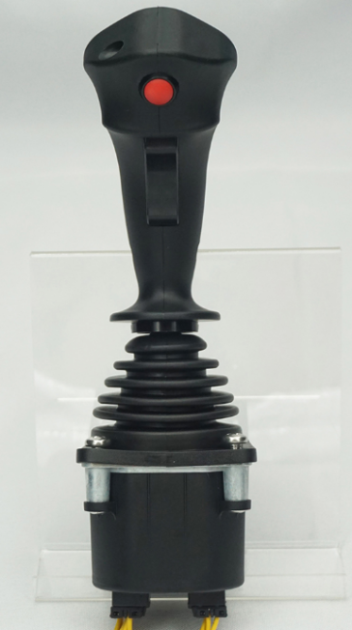
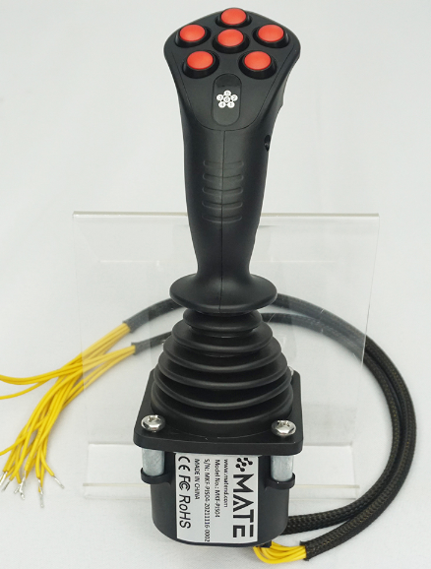

APPLICATION
Typical application on Cranes, loaders. Forklifts, excavators, access platform, tractors, harvesters, and so
on.

DESCRIPTION

- Ergonomics design on mobile application.
- Contactless hall effect and long expect-life potentiometer optional.
- Various handle, different number and location of button.
- Switches optional.
- CAN bus output optional.

7
6
5
4
3
2
1

Output Connection
D (Only for Deutsch
connector
A (AMP connector)
L Output directly
Microswitch
MS01 Without microswitch
MS06 With 4A before and after microswitch (not available for dual-axis cross directional operated)
Spring
M (Breakout force 5N)
Series
MKF-PJS04

Handle
MHA top without button
MHAS top with button
MHD top without button
MHDS top with button
MHDR top with rocker switch
MKG DN with dead man switch, without rocker switch
MKG DR with dead man switch and rocker switch
MSS See SS page
MSA See SA page
MSP See SP page
Output signal
Potentiometer (power supply< 36Vdc)
P05A 5KΩ potentiometer, 0%~100%Vdc output
P05B 5KΩ potentiometer, 10%~90%Vdc output
P05C 5KΩ potentiometer, 25%~75%Vdc output
P10A 10KΩ potentiometer, 0%~100%Vdc output
Hall (Power supply 5Vdc)
H01 each axis of single hall, 0.5~2.5~4.5Vdc output
H02 each axis of single hall, 0~2.5~5Vdc output
H03 each axis of single hall, 1.25~2.5~3.75Vdc output each
H04 axis of single hall, 1.0~2.5~4.0Vdc output
H05 each axis of single hall, 1.15~2.5~3.85Vdc output
2H01 each axis of redundant hall, 0.5~2.5~4.5Vdc output
2H02 each axis of redundant hall, 0~2.5~5Vdc output
2H03 each axis of redundant hall, 1.25~2.5~3.75Vdc output
2H04 each axis of redundant hall, 1.0~2.5~4.0Vdc output
2H05 each axis of redundant hall, 1.15~2.5~3.85Vdc output
With electronic amplifier
WV21 18~36Vdc power supply , -10V~0V~ + 10V output
WV22 18~36Vdc power supply , +10V~ 0V~ +10V output
WV23 18~36Vdc power supply , -5V~0V~ +5V output
WV24 18~36Vdc power supply , +5V~0V~ + 5V output
WI21 9~36Vdc power supply , 2-wire system 4mA~12mA~20mA output
WI22 9~36Vdc power supply , 2-wite system 20mA~4mA~20mA output
CAN BUS(9~36Vdc power supply)
WJ33 Can 2.0B output, source address 33
WJ34 Can 2.0B output, source address 34
WJ35 Can 2.0B output, source address 35
WJ36 Can 2.0B output, source address 36
NA Without analog signal output

Operating Limiter
1X (X Single axis)
1Y (Y Single axis)
2P (dual-axis for cross direction)
2C (dual-axis for any direction)

Electrical data
Potentiometer
Power supply | <36Vdc
Resistance | 2KΩ, 4KΩ, 5KΩ, 10KΩ
Electrical angle | ±18°
Center voltage | 48%~52%Vdc (Power supply)
Center tap angle | ±2.5°
On-load voltage (max) | 32Vdc
Power dissipation | 0.25W ( 25°)
Hall
Power supply | 5±0.5Vdc
Supply current | <11mA (Each of hall )
Maximum allowable overload voltage | 20Vdc
Reverse maximum allowable voltage | -10Vdc
Output linearity tolerance | <±4V
Directional switch
Load capacity | 2mA@30Vdc (Resistance load)
Breakout angle | ±3°~ 5°
Contact resistance | <200Ω
With electronic amplifier
Power supply | 18~36Vdc (U21~U24) 9~36Vdc
Power current consumption | <20mA
Maximum output current | 10mA
CAN BUS
Power supply | 9~36Vdc
CAN Version | CAN 2.0B
Protocol | J1939
Connector | 6 p-pin (Deutsch)
Microswitch
Load capacity | 4A@30Vdc (Resistance load)
Expecting life | 30 million times (Mechanical) 200 thousand times (Electrical)
Insulation resistance | >100MΩ
Breakout angle | ±3°~ 5°

Mechanical features
Travel angle | ±20°
Operating type | Spring return
Breakout force | 7N
Operating force(max) | 16N
Maximum allowable force | >300N
Expecting life | >2million cycles (Potentiometer) >5 million cycles (Hall effect)
Weight | 475g (Without handle)

Environmental data
Operating Temperature | -30℃~+70℃
Storage Temperature | -40℃~+85℃
Protection level | IP65 (Above the flange)

Dimensions
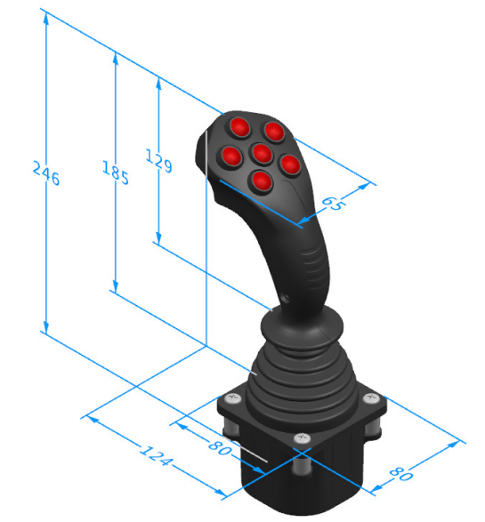

Product installation

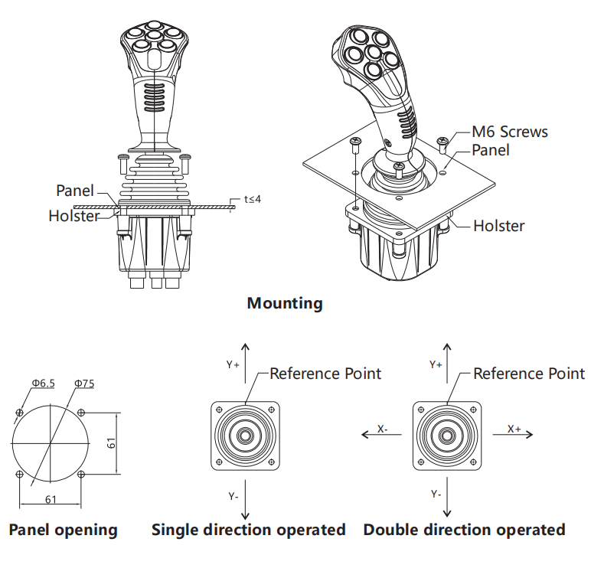

Electrical Connections

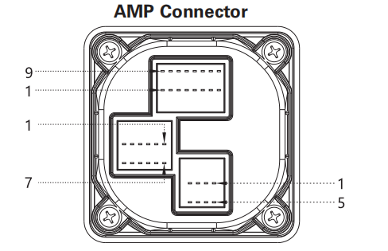

Pin | Pontentiometer | Hall | w/ electrical amplifier of output voltage | W/ electrical amplifier of output current
1 | Y-axis forward directional switch | Button switch 4 | Common terminal of button switch | Common terminal of button switch
2 | N/A | Button switch 3 | Button switch 1 | Button switch 1
3 | X-axis port left terminal | Button switch 2 | Button switch 2 | Button switch 2
4 | X-axis port wiper | Button switch 1 | Button switch 3 | Button switch 3
5 | X-axis port right terminal | Top button | Button switch 4 | Button switch 4
6 | X-axis port right terminal | Button switch 5 | Button switch 5 | Button switch 5
7 | X-axis switch common terminal | Button switch 6 | Button switch 6 | Button switch 6
8 | X-axis left directional switch | Deadman switch | Top button | Top button
9 | Y-axis port backward terminal | Button switch 9 | Deadman switch | Deadman switch
10 | Y-axis port wiper | Button switch 10 | Deadman switch | Deadman switch
11 | Y-axis port forward terminal | Common terminal of button switch | X-axis left directional switch | X-axis left directional switch
12 | Y-axis port center tap | Deadman swtich | X-axis port right terminal | X-axis port right terminal
13 | Y-axis switch common terminal | N/A | Y-axis backward directional switch | X-axis switch common terminal
14 | Y-axis backward directional switch | N/A | Y-axis forward directional switch | Y-axis forward directional switch
15 | X-axis right directional switch | N/A | Switch common terminal | Y-axis forward directional switch
16 | N/A | N/A | N/A | Y-axis switch common terminal
16 Pin

Pin | Pontentiometer | Hall
1 | Button switch 4 | +5V +5V(redundant hall)
2 | Button switch 3 | 0V( redundant hall)
3 | Button switch 2 | +5V power supply
4 | Button switch 1 | 0V power supply
5 | Top button | Y-axis output(redundant hall)
6 | Button switch 5 | X-axis output
7 | Button switch 6 | X-axis output(redundant hall)
8 | Deadman switch | Y-axis output
9 | Button switch 9 | Z1-axis output
10 | Button switch 10 | Z2-axis output
11 | Common terminal of button switch | Z-axis output(redundant hall)
12 | Deadman swtich | Z2-axis output(redundant hall)
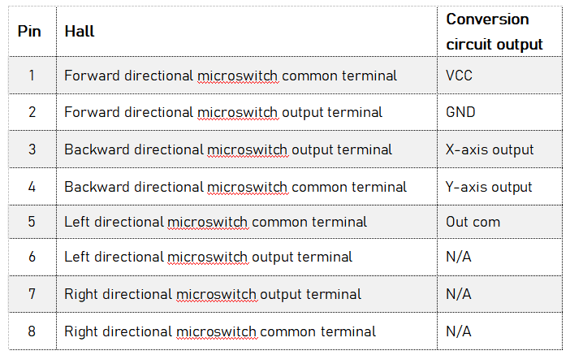
12 Pin 8 Pin

Electrical Connections

Pin | Can output | Color
1 | GND | Black
2 | VCC | Red
3 | CAN high | Yellow
4 | CAN low | Green
5 | CAN shield | N/A
6 | N/A | N/A
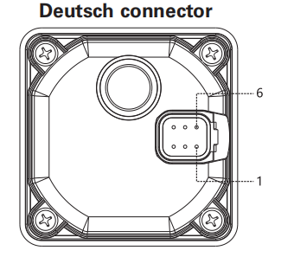

Handle Optional

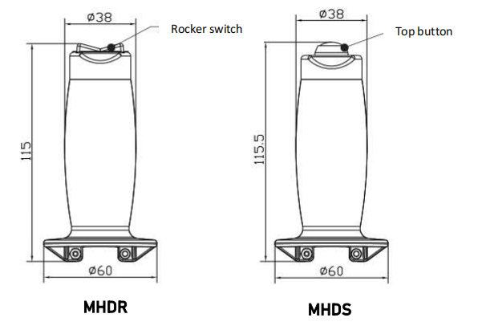
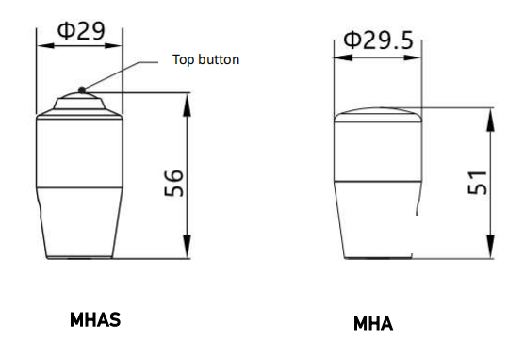

MKG DN with enabling switch, No rocker switch
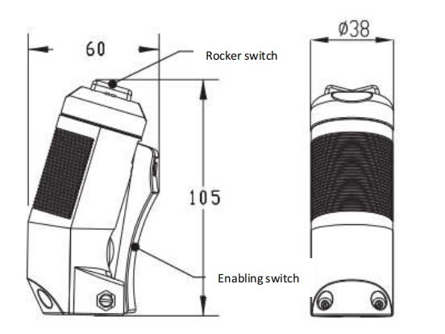
MKG DR with enabling switch, with rocker switch

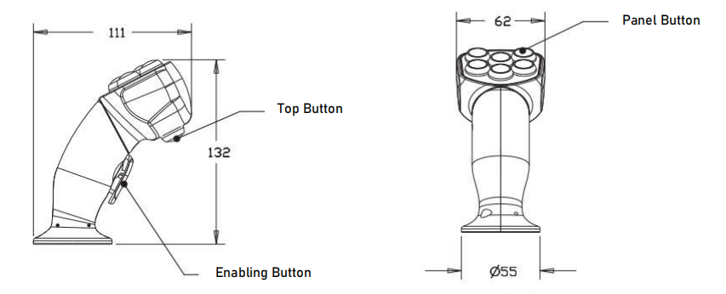

MSA

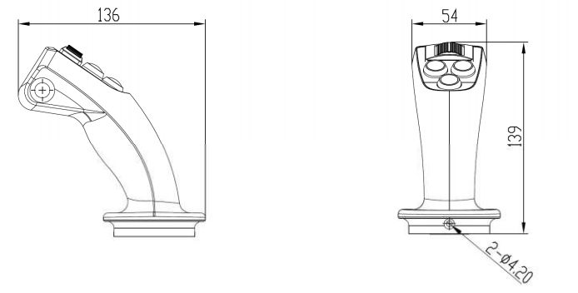

MSP
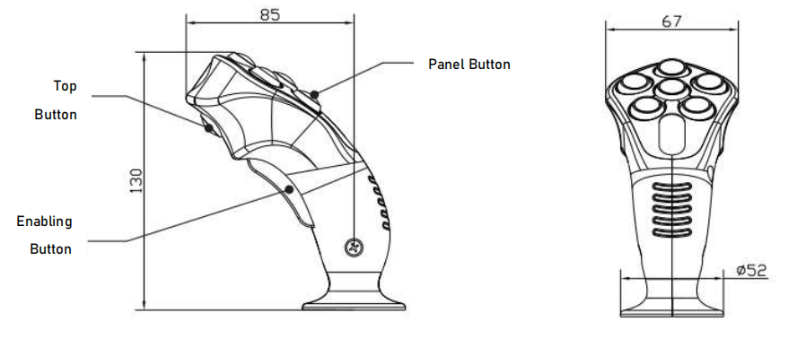

MSS

